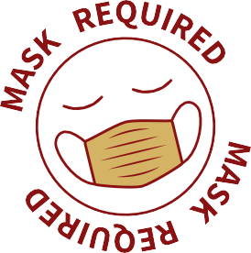

The Countdown Is On!
We have officially completed over 40 days of school and are heading into Fall Break. As the break approaches, I want you to reflect on what you have done in the past in hopes to do and become a better person for the future. If you are not satisfied where you are, work harder to get that point. - Miss Reid
-

Senior Row Nights
Senior Row Nights at Salem High
School are from 5:30PM - 7PM BY
APPOINTMENT ONLY!
Wed, Oct 13th Wed, Nov 3rd Wed, Dec 1st Wed, Jan 12th Wed, Feb 2nd
Wed, Mar 2nd * CAP & GOWN ORDER DEADLINE*
Senior Row Night Purpose
Speak with a Herff Jones Rep face-to-face about your cap & gown order
Make purchases towards your cap & gown and senior accessories
Acquire college and career information Acquire information for clearing your SHS fines

Click the following links to access:
Recording from Sept Senior Row Night

Senior Catalog
Order Cap & Gown Online
Book October 13th Senior Row Night Appointment

ACT Testing & Registration Schedule

SAT Testing & Registration Schedule

Frequently Asked Questions

Send a
text to 81010
& text this
message:
@seminolese
s

CONTACT INFORMATION

Dr. Medlock-Igbo
COUNSELOR SERVING LAST NAMES A-D
E-Mail rmedlockigbo@rockdale.k12.ga.us

Mr. Demmons
COUNSELOR SERVING LAST NAMES E-K
E-Mail jdemmons@rockdale.k12.ga.us

Mrs. Latiomore
COUNSELOR SERVING LAST NAMES L-ROC
E-Mail klatimore@rockdale.k12.ga.us

Ms. Anderson
COUNSELOR SERVING LAST NAMES ROD-Z
E-Mail canderson@rockdale.k12.ga.us

Mrs. Register
GRADUATION COACH & CEREMONY DIRECTOR
E-Mail mshafiq@rockdale.k12.ga.us

Miss Reid
SENIOR CLASS COORDINATOR
E-Mail treid@rockdale.k12.ga.us
*Due to Miss Reid teaching during the day, please allow a 1-2 business day response.

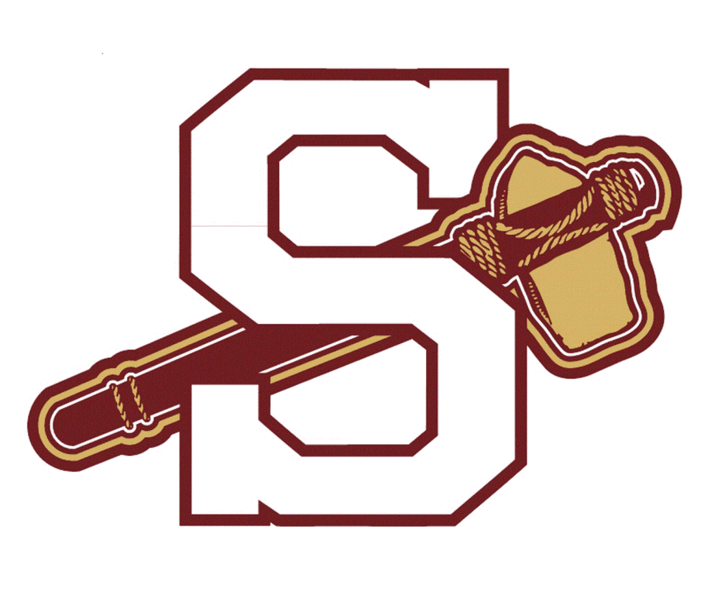

Follow the Senior Class page & SHS College & Career Center On:

@seminoleseniors_ @shscollegebound

